Project Design Phase-II Technology Stack (Architecture & Stack)

|  |  |
| --- | --- |
| Date | 26 October 2022 |
| Team ID | PNT2022TMID40966 |
| Project Name | Fertilizers Recommendation System For Disease Prediction |
| Maximum Marks | 4 Marks |

Technical Architecture:

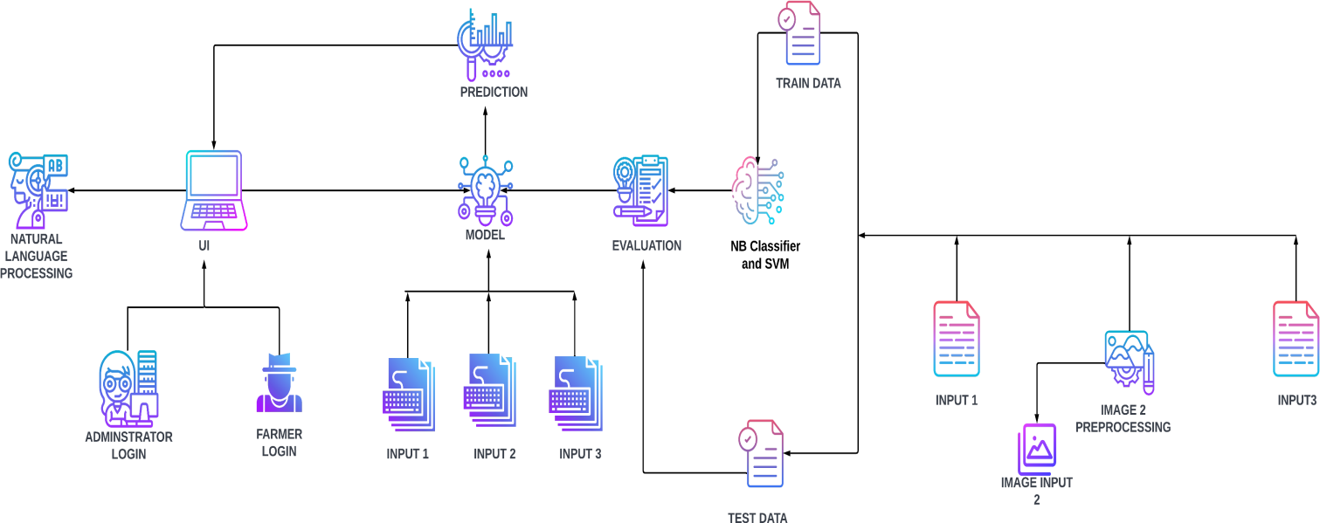

Table-1 : Components & Technologies

|  |  |  |  |
| --- | --- | --- | --- |
| **S.N**  **o** | **Component** | **Description** | **Technology** |
| 1. | User Interface | How the user interacts with the application .To depict the human-computer interaction and  communication. | HTML, CSS,JSP |
| 2. | Application Logic-1 | A page to upload images as input | Python |

|  |  |  |  |
| --- | --- | --- | --- |
| 3. | Application Logic-2 | To use the Machine Learning model and  predicting the result | Python |
| 4. | Database | Structured data-images | MySql |
| 5. | Cloud Database | Database that typically runs on a cloud computing platform and access to the database is provided as-a- service | IBM Cloud Databases for MySQL |
| 6. | File Storage | To store data in a hierarchicalstructure | Local File system |
| 7. | Machine Learning Model | Here, we use a Support Vector Machine Algorithm that is used widely in Classification and Regression problems. | Random Forest ,XG Boost |

Table-2: Application Characteristics:

|  |  |  |  |
| --- | --- | --- | --- |
| **S.No** | **Characteristics** | **Description** | **Technology** |
| 1. | Open-Source Frameworks | Flask micro web framework | Written in Python. It is classified as a micro frame work because it does not require particular tools or libraries. It has no database abstraction layer, form validation, or any other  components where preexisting  third-party libraries provide common functions. |
| 2. | Security Implementations | With all aspects of the job, including detecting malicious attacks, analyzing the network endpoint protection and vulnerability assessment, Sign in encryption | IBM Cloud App ID Services |

|  |  |  |  |
| --- | --- | --- | --- |
| 3. | Availability | Available for all data size | - |
| 4. | Performance | Can extend the storage according to our needs | Python,AngularJS |